Lab_2

Progressbar

**Develop an app to display a progress Bar and show a message with alert dialog.**

Step1 : Create a new Project and Wait for the Gradle build.

Step2 : Add the Progress Bar and Button from the Palette

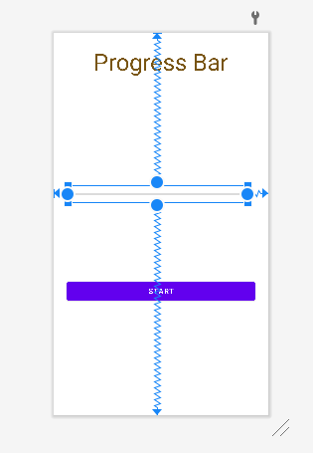

XML Code of Activity_main.xml

<**Button  
 android:id="@+id/button"  
 android:layout_width="match_parent"  
 android:layout_margin="25dp"  
 android:layout_height="wrap_content"  
 android:text="Start"  
 app:layout_constraintBottom_toBottomOf="parent"  
 app:layout_constraintEnd_toEndOf="parent"  
 app:layout_constraintHorizontal_bias="0.498"  
 app:layout_constraintStart_toStartOf="parent"  
 app:layout_constraintTop_toTopOf="parent"  
 app:layout_constraintVertical_bias="0.702"** />  
  
<**ProgressBar  
 android:id="@+id/progressBar2"  
 style="?android:attr/progressBarStyleHorizontal"  
 android:layout_width="345dp"  
 android:layout_height="32dp"  
  
  
 app:layout_constraintBottom_toBottomOf="parent"  
 app:layout_constraintEnd_toEndOf="parent"  
 app:layout_constraintHorizontal_bias="0.392"  
 app:layout_constraintStart_toStartOf="parent"  
 app:layout_constraintTop_toTopOf="parent"  
 app:layout_constraintVertical_bias="0.418"** />  
  
<**TextView  
 android:id="@+id/textView"  
 android:layout_width="wrap_content"  
 android:layout_height="wrap_content"  
 android:text="Progress Bar"  
 android:textSize="45dp"  
 android:textAlignment="center"  
 android:textColor="#785412"  
 app:layout_constraintBottom_toTopOf="@+id/progressBar2"  
 app:layout_constraintEnd_toEndOf="parent"  
 app:layout_constraintHorizontal_bias="0.498"  
 app:layout_constraintStart_toStartOf="parent"  
 app:layout_constraintTop_toTopOf="parent"  
 app:layout_constraintVertical_bias="0.106"** />

Java Code for MainActivity

**public** Button **button**;  
 ProgressBar **Progress**;  
 CountDownTimer **t**;  
 **float total**;  
  
 @Override  
 **protected void** onCreate(Bundle savedInstanceState) {  
 **super**.onCreate(savedInstanceState);  
 setContentView(R.layout.***activity_main***);  
 **button**=findViewById(R.id.***button***);  
 **Progress**=findViewById(R.id.***progressBar2***);  
  
 **Progress**.setVisibility(View.***INVISIBLE***);  
 **Progress**.setMax(100);  
 **button**.setOnClickListener(**new** View.OnClickListener() {  
 @Override  
 **public void** onClick(View view) {  
 **Progress**.setVisibility(View.***VISIBLE***);  
 **long** min= 10*1000;*//second * milisecond;* **new** CountDownTimer(min,1000)  
 {  
 @Override  
 **public void** onTick(**long** l) {  
 **long** a = min-l;  
 **total**= ((**float**)a/(**float**)min)*100;  
 Log.*e*(**"Total"**, String.*valueOf*( (a/min)));  
 **Progress**.setProgress((**int**) **total**);  
 }  
  
 @Override  
 **public void** onFinish() {  
 AlertDialog.Builder d = **new** AlertDialog.Builder(MainActivity.**this**);  
 d.setTitle(**" Completed "**).setMessage(**" Loding as Been Completed"**).setPositiveButton(**"Yes"**, **new** DialogInterface.OnClickListener() {  
 @Override  
 **public void** onClick(DialogInterface dialogInterface, **int** i) {  
 Toast.*makeText*(MainActivity.**this**,**"DOne"**,Toast.***LENGTH_LONG***).show();  
 }  
 });  
 AlertDialog dialog = d.create();  
 dialog.show();  
 }  
 }.start();  
*//* }  
 });  
 }

Output

